|  |  |  |
| --- | --- | --- |
| 8 | **.**  **.**  **.**  **.**  **.**  **.**  **.**  **.**  **.**  **.**  **.**  **.**  **.**  **.**  **.**  **.**  **.**  **.**  **.**  **.**  **.**  **.**  **.**  **.**  **.**  **.**  **.**  **.**  **.**  **.**  **.** | **Processes, Organizations, and Information Systems** |

|  |  |
| --- | --- |
| CHAPTER LEARNING OBJECTIVE QUESTIONS |  |

8-1 What Are the Basic Types of Processes?

8-2 How Can Information Systems Improve Process Quality?

8-3 How Do Enterprise Systems Solve the Problems of Departmental Silos?

8-4 How Do CRM, ERP, and EAI Support Enterprise Processes?

8-5 What Are the Challenges of Implementing and Upgrading Enterprise Information Systems?

8-6 How Do Inter-Enterprise IS Solve the Problems of Enterprise Silos?

Learning Catalytics™ is a student response tool that helps you generate class discussion, customize your lecture, and promote peer-to-peer learning based on real-time analytics. Learning Catalytics uses students’ smartphones, tablets, or laptops to engage them in more interactive tasks.

|  |  |
| --- | --- |
| SO WHAT? |  |

## Digital Dining

1. *Take a few minutes to reflect on the nature of the work your friends do for a living. How many of those jobs could be outsourced to robots? What jobs wouldn’t be outsourced?*

Student responses will vary. Generally, students will recognize that jobs required routine, physical tasks are more vulnerable to automation, while jobs requiring person to person interactions, judgment, and knowledge are less vulnerable to automation.

1. *When was the last time you interacted with a process that had been automated? What role did human workers previously fill? What roles are now carried out by machines? Is this automated process more efficient/effective now that it is automated? Are there ways in which humans were actually better at executing this process?*

Students will identify many different examples of automated processes. In some cases, the automated process works as well or better than the human-based process, but in some cases, the automated process is less effective due to its rigidity and time it takes to complete.

1. *Flippy the burger-flipping robot underwent rigorous testing before being deployed in restaurants. However, would you have any reservations about eating food prepared by a robot? Are there other applications of robots in which you would be uncomfortable with them replacing human workers?*

Since this is an opinion question, student responses will vary. Robotic applications that are more personal in nature are likely to provide examples in which students are uncomfortable with human replacements (e.g., dental hygienists).

1. *The debate over promoting innovation/automation versus endangering jobs is a common theme in the news. Do you agree that workers and the overall economy will be able to adapt over time and replace as many jobs as are taken via automation?*

This is an opinion question; students’ responses will vary.

|  |  |
| --- | --- |
| COLLABORATION EXERCISE 8 |  |

## The County Planning Office

*Using the collaboration IS you built in Chapter 1 (pages 25–26), collaborate with a group of students to answer the following questions. If you haven’t built your collaboration IS yet, reread Collaboration Exercise 1 and Chapter Extension 10. Meet with your team and build a collaboration IS that uses tools like Google Docs, SharePoint, or other collaboration tools. Do not forget the need for procedures and team training.*

1. *Explain why the processes in Figures 8-14 and 8-15 are classified as enterprise processes rather than as departmental processes. Why are these processes not considered to be inter-enterprise processes?*

These processes span the entire enterprise including several different departments, but do not span separate organizations. Therefore they are considered enterprise systems, not departmental and not interorganizational. (LO: 1, Learning Outcome: Describe the uses of enterprise systems and enterprise resource planning, AACSB: Analytical Thinking)

1. *Using Figure 8-7 as an example, redraw Figure 8-14 using an enterprise information system that processes a shared database. Explain the advantages of this system over the paper-based system in Figure 8-14.*

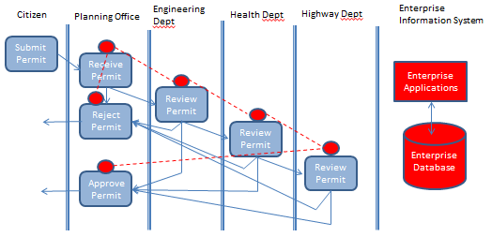

The process is sequential and each stage can take quite a bit of time. With the old system, there is no way to know where an application was in the process, and finding an application sitting in someone’s inbox could be difficult. With the new system, it will be easy to track the application and know its status, plus it can be routed to the correct next step immediately. (LO: 2, Learning Outcome: Describe the uses of enterprise systems and enterprise resource planning, AACSB: Analytical Thinking)

1. *Using Figure 8-7 as an example, redraw Figure 8-15 using an enterprise information system that processes a shared database. Explain the advantages of this system over the paper-based system in Figure 8-15.*

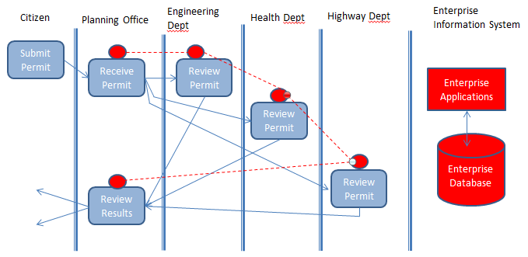

The advantage of this system over the paper-based system is that there is no expense to copy the application and send copies to each department for review. The departments can work simultaneously and can also see the results of the other departments’ analyses that are recorded in the centralized database. (LO: 2, Learning Outcome: Describe the uses of enterprise systems and enterprise resource planning, AACSB: Analytical Thinking)

1. *Assuming that the county has just changed from the system in Figure 8-14 to the one in Figure 8-15, which of your answers in questions 8-5 and 8-6 do you think is better? Justify your answer.*

The ability to work simultaneously and also to have access to the results of the other department’s work tips the balance in favor of the solution in question 8-3. This workflow should be more efficient and effective than that shown in question 8-2. (LO: 2, Learning Outcome: Describe the uses of enterprise systems and enterprise resource planning, AACSB: Analytical Thinking)

1. *Assume your team is in charge of the implementation of the system you recommend in your answer to question 8-7. Describe how each of the five challenges discussed in section 8-5 pertain to this implementation. Explain how your team will deal with those challenges.*

* Collaborative management—there is no single manager of the process so all of the departments have to coordinate to complete the process. Disputes will have to be resolved with a collaborative process, which probably does not currently exist.
* Requirements gaps—an enterprise software solution will probably not fit the needs of this system exactly, so the organization usually must adapt to the software’s processes.
* Transition problems—changing to the new system will be challenging to the organization and will cause some disruption in productivity.
* Employee resistance—employees’ natural resistance to change and fear of change must be overcome through leadership and training.
* New technology—the solution will be affected by new technologies as they evolve, particularly the use of the cloud and mobile technology.

(LO: 3, Learning Outcome: Describe the uses of enterprise systems and enterprise resource planning, AACSB: Analytical Thinking)

|  |  |
| --- | --- |
| CASE STUDY 8 |  |

## A Tale of Two Interorganizational IS

1. *Summarize the purpose and intended benefits of a healthcare exchange.*

A healthcare exchange is a mechanism that enables people to shop for and obtain health insurance coverage. Exchanges are intended to help people determine the best coverage based on each person’s specific situation. (LO: 7, Learning Outcome: Discuss the role of information systems in supporting business processes, AACSB: Analytical Thinking)

1. *Explain why a health care exchange requires an interorganizational information system.*

The exchanges are definitely interorganizational, because the exchange takes a person’s personal data and contacts a variety of governmental agencies to determine eligibility for government programs. Then insurance programs are evaluated to find the best fit for that person’s situation. (LO: 7, Learning Outcome: Discuss the role of information systems in supporting business processes, AACSB: Analytical Thinking)

1. *Using knowledge from this chapter, summarize the difficulties and challenges of developing interorganizational information systems.*

Interorganizational systems increase the complexity of a development process significantly. Each organization has its own goals and objectives for the project, which may be very different. Each organization has different ways of developing and managing the project. Communication between the organizations may be lacking. There is typically not a single leader for the project and each organization’s managers may have different views of the project. The lack of a common goal and a single vision for the project plus potentially different levels of management oversight can make these projects very difficult to complete successfully. (LO: 7, Learning Outcome: Discuss best practices for selecting, evaluating, and managing information systems projects, AACSB: Analytical Thinking)

1. *Healthcare exchanges must utilize personal and confidential data about their users. Write a one-paragraph policy that stipulates responsible processing and storage of these data.*

Security of this data is paramount and users must have confidence that their information is safe or they will be unwilling to trust and use the system. Because of the sensitivity of health data, it would be appropriate that all data be stored in encrypted form and all data transmissions also be encrypted. (LO: 7, Learning Outcome: Describe different methods of managing IS security, AACSB: Analytical Thinking)

1. *Explain what you believe are the reasons for the Access CT success.*

The managerial structure for the project helped provide a single vision for the project. The leadership did not allow the teams involved in the project to work at cross purposes. People with an excellent background and skills were hired for the project, so clearly the project was funded appropriately to hire the best possible talent, not just the cheapest. (LO: 7, Learning Outcome: Discuss best practices for selecting, evaluating, and managing information systems projects, AACSB: Analytical Thinking)

1. *Read the Executive Summary of the First Data report located at:* https://docplayer.net/179032-Cover-oregon-website-implementation-assessment-report.html. *Summarize those findings.*

The Executive Summary provides a good overview of challenges and difficulties encountered on this project. One of the strongest themes learned from this material was the lack of a single point of authority for the project. There were numerous examples of contradictory decisions and teams working at cross purposes. Many good project management practices were ignored. Budget limitations prevented some of the needed contributors from participating (e.g., a systems integrator). The lack of management oversight is also a strong theme that emerged. (LO: 7, Learning Outcome: Discuss best practices for selecting, evaluating, and managing information systems projects, AACSB: Analytical Thinking)

1. *Using the facts described in this case and your answer to question 8-14, list five key learnings you can take from the Access CT and Cover Oregon projects.*

Students’ lists may vary, but will most likely include the following items:

* Strong and visible top management support and involvement
* Single point of authority
* Team members with appropriate background and skills
* Follow best practices for management of complex IT projects
* Ensure accountability from all team contributors

(LO: 7, Learning Outcome: Discuss best practices for selecting, evaluating, and managing information systems projects, AACSB: Analytical Thinking)

For an example illustrating the concepts found in this chapter, view the videos in [mymislab.com](http://mymislab.com/).